DAA HACKATHON — PROJECT REPORT
SERVERFLOW
Simulating request routing with a Greedy Algorithm and a Priority Queue
Subject | Design and Analysis of Algorithms
Problem Statement | Problem Statement 71 — Server Request Load Distributor
Core Algorithms | Greedy Algorithm and Priority Queue
Suggested Technologies | Python, Flask, JavaScript
Hackathon / Project Designation | DAA Hackathon — Algorithm-Centric Prototype
Team Members | P . Niklesh  K . Vinay kumar  G . Ravi teja  A.Gouri shankar

1. Abstract
Modern web services receive a continuous stream of requests that must be spread across several servers. When the spread is uneven, some servers accumulate long queues while others sit idle, which increases waiting time and lowers the quality of service for every user. This project addresses Problem Statement 71: Server Request Load Distributor, which asks for a simulation of request routing to servers in which the target server is selected using queue length, capacity or response-cost estimates.
The proposed system is an algorithm-centric prototype built with Python, Flask and JavaScript. Each server is described by its capacity, its current queue length, its pending work and a fixed latency estimate. From these values the system computes a response-cost estimate for every candidate server, which combines how long a new request would wait behind existing work with how quickly the server can process it. Queue length and capacity are therefore both reflected in a single comparable number, and the selection criterion is stated explicitly rather than hidden inside the code.
Two core algorithms drive the design. A Priority Queue, implemented as a binary min-heap, stores incoming requests and always releases the most urgent one first, with arrival order used to break ties. A Greedy Algorithm then examines the available servers for that request and irrevocably chooses the server with the lowest response-cost estimate, with deterministic tie-breaking. Both choices are made in logarithmic or linear time, so a simulation of R requests over S servers costs O(R log R + R·S) in the implementation described here.
The greedy rule is a heuristic; it makes the best local decision for each request and does not claim to produce a globally optimal schedule. The expected outcome is a system that makes every routing decision visible, shows queue and load changes after each assignment, and reports waiting time, utilisation and request distribution so that the behaviour of the algorithms can be understood, explained and compared in a Design and Analysis of Algorithms setting. All numerical results in this report are illustrative worked examples, not measurements from a production deployment.
Keywords: load balancing, request routing, Greedy Algorithm, Priority Queue, binary heap, response-cost estimate, Flask, simulation.
Table 1: Project Summary
Item | Summary
Problem | Route simulated requests to servers using queue length, capacity or response-cost estimates (Problem 71)
Selection criterion | Lowest response-cost estimate E(s, r) = d(s) + (L(s) + c(r)) / C(s); ties broken by queue length, then server ID
Request ordering | Min-heap keyed on (priority, arrival time, request ID); priority 1 is the most urgent
Technologies | Python (heapq), Flask for the REST API, HTML, CSS and JavaScript for the dashboard
Outputs | Selected server, reason, queue status, utilisation, waiting time, response-cost information, routing history
Table 2: Organisation of the Report
Pages | Content
2 – 4 | Abstract, introduction, existing and proposed approach
5 – 7 | Problem statement, objectives, scope and limitations
8 – 10 | Major features, functional and non-functional requirements, system workflow
11 – 14 | Greedy Algorithm, Priority Queue, combined methodology, complexity analysis
15 – 16 | Technologies used and system implementation
17 – 20 | Sample results, testing, performance analysis, conclusion, future scope and references

2. Introduction

2.1 Background of Server Request Distribution
Every web application, API or online service is ultimately a program running on one or more servers. A server can only work on a limited number of requests at a time; the rest wait in a queue. As soon as the number of users grows beyond what a single machine can handle, the service is deployed on several servers, and a component in front of them must decide which server should receive each incoming request. This decision is called request routing, and the component that makes it is commonly called a load balancer or load distributor.

2.2 Multiple Servers Handling Incoming Requests
In a multi-server setting the servers are rarely identical. One may have a faster processor, another may already be busy with a long job, and a third may sit further away on the network. Each server therefore has its own capacity (how much work it can process per unit of time), its own queue length (how many requests are already waiting) and its own response cost (how long a new request is expected to take from arrival to completion). A routing decision that ignores these differences treats unequal machines as if they were equal.

2.3 Problems Caused by Uneven Distribution
When requests are distributed unevenly, a few servers become overloaded while others remain under-used. Overloaded servers produce long waiting times, time-outs and, in the worst case, dropped requests. Under-used servers waste capacity that has already been paid for. Urgent requests may also be stuck behind routine ones, so the user-visible delay depends on luck rather than on importance.

2.4 Importance of Load Balancing
Load balancing keeps the work spread across the available servers so that no single server becomes a bottleneck. A good strategy shortens the average waiting time, makes better use of capacity, keeps response times predictable and allows a system to serve more users with the same hardware. It is therefore a basic building block of reliable service design and a natural subject for algorithmic study.

2.5 Motivation for the Proposed System
Production load balancers are complex and their routing logic is difficult to observe. For a Design and Analysis of Algorithms project, it is more valuable to build a small prototype in which the decision rule is explicit, every decision is recorded and the effect of each decision on queue lengths and load can be seen step by step. The proposed Server Request Load Distributor simulates exactly this: requests arrive, servers are evaluated, one server is chosen, and the new state is displayed.

2.6 Role of Algorithms in Routing Decisions
Two classical algorithmic ideas are sufficient to build the routing core. A Priority Queue decides the order in which waiting requests are handled, so urgent requests are not delayed by routine ones. A Greedy Algorithm decides where each request goes by always taking the best server available at that moment according to a clearly defined criterion. Together they convert the informal goal “spread the load sensibly” into precise, analysable steps whose time and space costs can be stated in Big-O notation.

3. Existing Approach and Proposed Approach

3.1 Basic and Manual Request Routing
The simplest way to route requests is to assign them by hand or by a fixed rule: always use the first server, rotate through the servers in turn (round robin), or choose a server at random. These methods are easy to implement and need no information about the servers, which is why they are widely used as defaults.

3.2 Limitations of Simple Routing
- Ignores server state: a rotation sends the next request to a server even if its queue is already long.
- Ignores capacity: a slow and a fast server receive the same share of requests.
- Ignores request importance: urgent requests wait in the same line as routine ones.
- Hard to explain: the user cannot see why a particular server was chosen.

3.3 Need for Algorithmic Routing
Because queue length, capacity and response cost all differ between servers, the routing step is really an optimisation problem that is repeated for every request. It needs a precise rule for comparing servers and an efficient structure for ordering requests. Both are provided by well-known algorithmic techniques, which is why Problem 71 lists a Greedy Algorithm and a Priority Queue as its core algorithms.

3.4 Proposed Server Request Load Distributor
The proposed system keeps all pending requests in a Priority Queue. Each time a request is released, the system evaluates every available server, computes a response-cost estimate and applies a greedy rule to select the server with the lowest estimate. The request is then assigned, the server’s queue and load are updated, and performance metrics are recalculated. Every step is written to a routing history so that the decision can be inspected afterwards.

3.5 High-Level Workflow
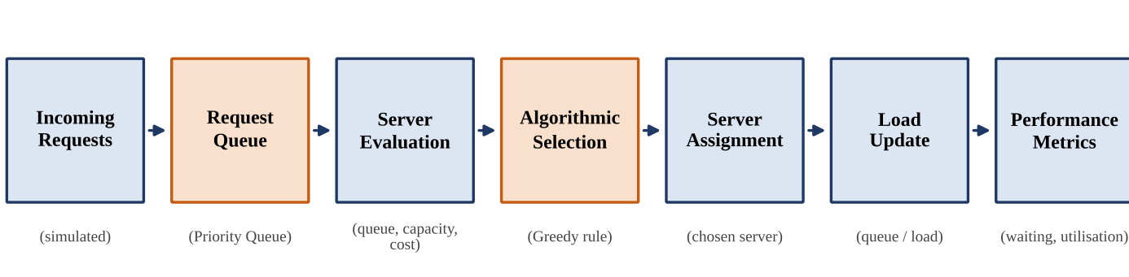
Figure 1: High-Level Server Request Distribution Workflow
Requests enter the request queue, where they are ordered by priority. Server evaluation gathers the queue length, capacity and response-cost estimate of each server. Algorithmic selection applies the greedy rule, server assignment dispatches the request, the load update refreshes the server state, and performance metrics summarise the effect on waiting time and utilisation.

4. Problem Statement

4.1 Official Problem Statement
Problem 71 — Server Request Load Distributor (Core algorithms: Greedy, Priority Queue; suggested technologies: Python, Flask, JavaScript). “Simulate request routing to servers and select servers based on queue length, capacity or response-cost estimates.”

4.2 Problem Definition
Given a set of servers and a stream of incoming requests, the task is to simulate the routing of every request to one of the servers. For each request the system must decide which server should receive it, using information about the servers’ queue lengths, capacities or response-cost estimates. The decision rule must be well defined and the result of each decision must be understandable to the user.

4.3 Input, Processing and Output
Table 3: Problem 71 — Input, Processing, Server Selection and Output
Stage | Description
Input | Number of servers; for each server its capacity C(s), current queue length q(s), pending work L(s) and latency estimate d(s); a stream of requests, each with an ID, priority, arrival time and estimated processing cost c(r).
Processing | Store requests in a Priority Queue; repeatedly extract the most urgent request; evaluate all available servers; assign the request; update server state; record the decision.
Server selection | Greedy choice of the feasible server with the best value of the configured criterion: queue length, capacity, response-cost estimate, or a weighted combination.
Output | Selected server and the reason for it, updated queue status, utilisation, waiting time, response-cost information and overall routing performance.

4.4 Routing Requirements
- Every request must be routed to exactly one server, or explicitly deferred if no server is available.
- The selection criterion must be defined explicitly and applied in the same way to every request.
- Servers that are unavailable or whose queue has reached its limit must not be selected.
- Urgent requests must be handled before routine ones; requests of equal priority are handled in arrival order.
- The reason for each routing decision must be stored and displayed.

4.5 Need for Optimisation
A naive assignment can send a request to a server that is already overloaded while a better server is idle. Since this choice is repeated for every request, even a small inefficiency accumulates into long waiting times. The system therefore needs a selection rule that is cheap to evaluate and consistently favours servers that can finish the request sooner. The rule used here is a greedy heuristic: it is fast and easy to explain, but it optimises one decision at a time and does not claim a globally optimal schedule.

5. Objectives
The project has ten objectives. Each one corresponds to a feature, an algorithmic component or a result presented later in the report.
Table 4: Project Objectives
No. | Objective | How the project addresses it
1 | Simulate incoming server requests. | Generate or enter requests with an ID, priority, arrival order and estimated processing cost so that a realistic stream of work can be reproduced and repeated.
2 | Represent multiple servers and their current states. | Model each server by capacity, queue length, pending work, latency estimate and availability, and keep this state up to date after every assignment.
3 | Select servers using queue length, capacity or response-cost estimates. | Provide a clearly defined selection criterion built from these three quantities, including the single response-cost estimate that combines them.
4 | Demonstrate the Greedy Algorithm. | Show the locally best choice made for each request, with the rule, tie-breaking and pseudocode stated explicitly.
5 | Demonstrate the Priority Queue. | Use a binary min-heap to hold pending requests and release the most urgent one first, with arrival order as the tie-breaker.
6 | Make routing decisions visible. | Display the evaluated servers, their scores, the chosen server and the reason for the choice, and keep a routing history.
7 | Reduce unnecessary waiting or load imbalance. | Prefer servers that can finish a request sooner so that long queues do not grow while other servers have spare capacity.
8 | Present understandable performance results. | Report average waiting time, utilisation, request distribution and queue lengths in tables and simple charts.
9 | Compare routing behaviour where appropriate. | Contrast the greedy rule with a plain rotation (round robin) on the same sample workload to show where state-aware routing helps.
10 | Demonstrate practical application of DAA concepts. | Connect greedy strategy, heap-based priority queues and Big-O analysis to a concrete, explainable system.
Objectives 4 and 5 are treated in detail in Chapters 10 and 11, objective 3 in Chapter 10, and objectives 6 to 9 are demonstrated through the sample results of Chapters 16 and 17. Objective 10 is addressed by the complexity analysis in Chapter 13.

6. Scope and Limitations

6.1 Scope
The project covers the following activities, all of which fall directly within Problem Statement 71:
- Multiple server simulation: a configurable set of servers is created and its state is tracked.
- Request generation: requests are generated automatically or entered manually.
- Server capacity representation: each server has a capacity expressed in work units per second.
- Queue management: queue length and pending work are updated after every assignment.
- Request routing: each request is routed to one server or deferred when none is feasible.
- Greedy server selection: the server with the best score for the configured criterion is chosen.
- Priority-based request handling: a Priority Queue orders requests by priority and arrival time.
- Performance measurement: waiting time, utilisation and request distribution are calculated.
- Visualisation / dashboard: a web page shows server load, the routing decision and the history.

6.2 Limitations
- Prototype, not production infrastructure: the system is a simulation and is not a production-grade distributed load balancer.
- Simulated response times: response times are computed from estimates, not measured from real network traffic.
- Configurable server parameters: capacities, latency estimates and queue limits are supplied by the user and do not change by themselves.
- No real distributed deployment: all servers are simulated inside one Flask process.
- Workload dependence: the results depend on the generated or entered workload and cannot be generalised without further testing.
- Heuristic nature: the greedy rule is not guaranteed to give a globally optimal distribution.
- Possible starvation: with a strict priority order, a steady flow of urgent requests can delay low-priority ones.

6.3 Out of Scope
Network protocols, health checks of real machines, authentication, persistent storage and automatic scaling are not part of the problem statement and are not implemented.

6.4 Assumptions
- The processing cost of each request is known as an estimate when the request is created.
- Servers do not fail during a run unless they are explicitly marked unavailable by the user.
- All servers are reachable at the same moment, and the latency estimate d(s) is fixed for the duration of a run.

7. Major Features
The prototype provides ten major features. The table below lists each feature together with the algorithm or software component that implements it.
Table 5: Major Features of the Server Request Load Distributor
Feature | Description | Algorithm / Component
Server configuration | Define the number of servers and set each server’s capacity, initial queue length, pending work, latency estimate and availability. | Server Management Module
Request generation / input | Create requests automatically with random priority and cost, or enter a request manually through a form. | Request Input Module
Request priority handling | Every request carries a priority from 1 (most urgent) upwards; equal priorities are served in arrival order. | Priority Queue (min-heap)
Queue monitoring | Show the number of pending requests, the next request to be served and the queue length of every server. | Priority Queue and Server State
Server selection | Evaluate each available server for the current request and compute its score under the chosen criterion. | Greedy Routing Module
Greedy routing | Assign the request to the feasible server with the lowest score; break ties by queue length, then by server ID. | Greedy Algorithm
Priority Queue management | Insert requests in O(log n), extract the most urgent request in O(log n) and report whether the queue is empty. | Priority Queue Module (heapq)
Load visualisation | Display queue length and pending work of each server as bars before and after each assignment. | Results / Visualisation Module
Performance metrics | Calculate average waiting time, utilisation, load spread and request distribution across servers. | Performance Analysis Module
Routing history | Record request, priority, scores of all servers, chosen server and reason for every decision. | Routing log (list of records)
These features are deliberately limited to what Problem Statement 71 requires. They form a closed loop: configuration and input feed the Priority Queue, the greedy module consumes requests from it, and the metrics and visualisation modules report the effect of each decision.

8. Functional Requirements
Table 6: Functional Requirements
ID | Requirement | Description
8.1 Input Requirements
FR-I1 | Number of servers | The user specifies how many servers take part in the simulation (at least one).
FR-I2 | Server capacity | Each server has a positive capacity C(s) in work units per second.
FR-I3 | Current queue length | Each server starts with a queue length q(s) and pending work L(s), both non-negative.
FR-I4 | Request priority | Each request has an integer priority; 1 is the most urgent.
FR-I5 | Estimated processing / response cost | Each request has a processing cost c(r); each server has a latency estimate d(s).
FR-I6 | Incoming request details | Request ID and arrival order are captured for every request.
8.2 Processing Requirements
FR-P1 | Store requests | All incoming requests are stored in the request structure without loss.
FR-P2 | Maintain Priority Queue | Requests are kept in a min-heap ordered by (priority, arrival, ID).
FR-P3 | Evaluate servers | For the extracted request, compute the score of every available server.
FR-P4 | Select suitable server | Apply the greedy rule with deterministic tie-breaking; skip unavailable or full servers.
FR-P5 | Assign request | Dispatch the request to the selected server, or defer it if none is feasible.
FR-P6 | Update server state | Increase q(s) by one and L(s) by c(r) for the chosen server.
FR-P7 | Record routing decision | Store the scores, the chosen server and the reason in the routing history.
8.3 Output Requirements
FR-O1 | Selected server | Show which server received each request.
FR-O2 | Queue status | Show the pending requests and the queue length of every server.
FR-O3 | Server utilisation | Show the share of work and the busy fraction of each server.
FR-O4 | Waiting time | Show the estimated waiting time of each request and the average over all requests.
FR-O5 | Response-cost information | Show the response-cost estimate of every evaluated server.
FR-O6 | Overall routing performance | Show load spread, distribution of requests and a summary of the run.
Requirements are numbered so that they can be traced to test cases in Chapter 17. Inputs that violate the stated ranges (for example a zero capacity) are rejected with an error message and do not change the system state.

9. Non-Functional Requirements and System Workflow
Table 7: Non-Functional Requirements
Attribute | Requirement
Performance | A routing decision costs O(log n + S); the dashboard must remain responsive for the workload sizes used in the demonstration.
Usability | Forms and tables use plain labels; every decision is shown with its reason so that it can be understood without reading code.
Reliability | Invalid input is rejected without changing state; the same input and tie-breaking always give the same routing result.
Scalability | The number of servers and requests is configurable; cost grows as O(R log R + R·S) in the simulation, within a single process.
Maintainability | The Priority Queue, the greedy selector and the metrics are separate modules, so a rule can be changed without touching the rest.
Responsiveness | The user interface updates after each API response without reloading the page.

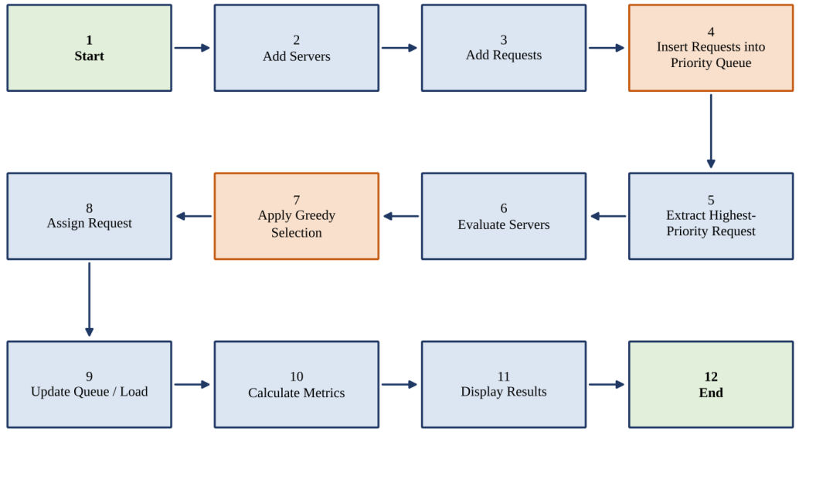
Figure 2: Detailed System Workflow
Table 8: Explanation of the Workflow Stages
No. | Stage | Explanation
1 | Start | The simulation is initialised with empty history and zero metrics.
2 | Add Servers | Servers are created with capacity, queue length, pending work and latency estimate.
3 | Add Requests | Requests are generated or entered with priority and processing cost.
4 | Insert into Priority Queue | Each request is pushed into the min-heap in O(log n).
5 | Extract Highest-Priority Request | The heap root, i.e. the most urgent and earliest request, is removed in O(log n).
6 | Evaluate Servers | The response-cost estimate of each available server is computed in O(S).
7 | Apply Greedy Selection | The server with the lowest estimate is chosen; ties are broken by queue length, then ID.
8 | Assign Request | The request is sent to the chosen server, or deferred if none is feasible.
9 | Update Queue / Load | The chosen server’s queue length and pending work are increased.
10 | Calculate Metrics | Waiting time, utilisation and load spread are recomputed.
11 | Display Results | The dashboard shows the decision, server states and history.
12 | End | The loop ends when the Priority Queue is empty.

10. Greedy Algorithm

10.1 Concept and Suitability
A Greedy Algorithm builds a solution step by step. At each step it makes the choice that looks best at that moment, according to a fixed criterion, and never revisits the choice. This is the greedy choice principle. Greedy methods are suitable here because routing is an online decision: a request must be dispatched when it is released, the decision cannot be undone, and the information needed for a good choice (queue length, capacity, response-cost estimate) is available immediately and can be evaluated cheaply.

10.2 Selection Rule
For a request r, the feasible servers are those that are available and whose queue length is below the limit Q_max. The exact criterion must be defined explicitly by the implementation; this prototype uses the response-cost estimate
E(s, r) = d(s) + ( L(s) + c(r) ) / C(s)
where d(s) is the latency estimate, L(s) the pending work, c(r) the cost of the request and C(s) the capacity of server s. The greedy choice is the feasible server with the smallest E(s, r); ties are broken by the smaller queue length q(s) and then by the smaller server ID. Simpler criteria are special cases: lowest queue length uses q(s), highest capacity uses C(s) / (q(s) + 1), and a weighted combination J(s, r) = w_q·q(s) + w_c / C(s) + w_e·E(s, r) uses weights set in the configuration (default w_e = 1, others 0).

10.3 Algorithm Steps
- Take the request r released by the Priority Queue.
- Discard servers that are unavailable or have q(s) ≥ Q_max.
- Compute E(s, r) for each remaining server.
- Choose the server with the smallest value; apply the tie-breaking rule if needed.
- Assign r, set q(s) ← q(s) + 1 and L(s) ← L(s) + c(r); if no server is feasible, defer r.

10.4 Pseudocode
GREEDY_SELECT(servers, r, policy):
best <- NIL
for each server s in servers: // O(S)
if not s.available or s.q >= Q_MAX: continue
key <- (score(s, r, policy), s.q, s.id) // O(1)
if best = NIL or key < bestKey:
best <- s; bestKey <- key
return best // NIL means: defer the request

10.5 Small Example
Request R7 has cost c = 10 and d(s) = 0.05 for all servers.
Table 9: Worked Example of Greedy Selection (Sample Values)
Server | C(s) | q(s) | L(s) | E(s, R7) | Lowest queue? | Highest capacity?
S1 | 10 | 5 | 50 | 6.05 | No | No
S2 | 20 | 6 | 60 | 3.55 | No | Yes
S3 | 5 | 2 | 20 | 6.05 | Yes | No
Choosing by queue length alone selects S3 (E = 6.05), and the greedy rule selects S2 (E = 3.55) because its high capacity outweighs its longer queue.

11. Priority Queue

11.1 Concept
A Priority Queue is an abstract data type that stores items with a priority and always removes the item with the best priority first, independent of the order in which items arrived. In a min-priority queue the smallest key is removed first; in a max-priority queue the largest key is removed first. The prototype uses a min-priority queue in which the key is the tuple (priority, arrival, request ID), so priority 1 (the most urgent) is released first and requests with equal priority are released in arrival order.

11.2 Why It Is Useful for Request Handling
A plain first-in-first-out queue would serve an urgent request only after all earlier routine requests. Re-sorting after every arrival would cost O(n log n). A binary min-heap keeps the smallest key at the root of an array and supports insertion and extraction in O(log n), the standard implementation of a priority queue (heapq in Python).

11.3 Operations and Representation
Table 10: Priority Queue Operations (Binary Min-Heap)
Operation | Description | Time
INSERT(Q, r) | Append the key, then move it up while smaller than its parent | O(log n)
EXTRACT-MIN(Q) | Remove the root, move the last item to the root, sift it down | O(log n)
PEEK(Q) | Read the root without removing it | O(1)
BUILD-HEAP(A) | Create a heap from n requests that are already known | O(n)

11.4 Pseudocode
PQ_INSERT(Q, r):
Q.append( (r.priority, r.arrival, r.id) )
SIFT_UP(Q, last index) // O(log n)

PQ_EXTRACT(Q):
if Q is empty: return NIL
top <- Q[0]; Q[0] <- Q.pop_last()
SIFT_DOWN(Q, 0) // O(log n)
return top

11.5 Example Request Sequence
Five requests arrive in the order R1 (p = 3), R2 (p = 1), R3 (p = 2), R4 (p = 1), R5 (p = 3). After the five insertions the heap is as shown in Figure 3, and the extraction order is R2, R4, R3, R1, R5: priority first, arrival order for equal priorities.
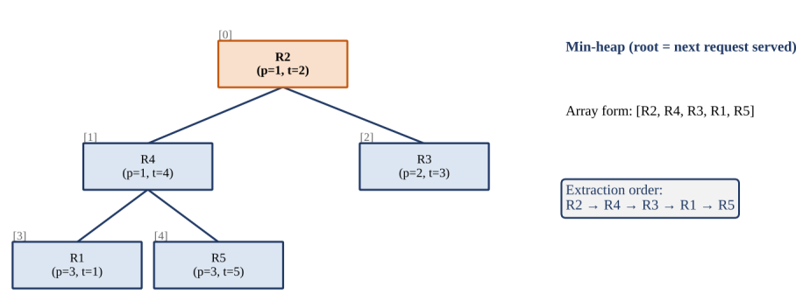
Figure 3: Min-Heap Representation of the Request Priority Queue

12. Combined Methodology
The Priority Queue and the Greedy Algorithm solve two different decisions. The Priority Queue answers “which request next?” and the Greedy Algorithm answers “which server for it?”. Because the Priority Queue releases one request at a time, the greedy step always works on a single, well-defined request, and the server state it sees already includes all earlier assignments.

12.1 Processing Steps
- Incoming requests arrive.
- Requests are assigned priorities and cost estimates.
- Requests enter the Priority Queue.
- The highest-priority request is selected (extracted).
- Available servers are evaluated.
- The greedy rule selects the best currently feasible server.
- The request is assigned to that server.
- The server’s queue length and pending work are updated.
- Metrics are recalculated.
- The process continues until all requests are handled.

12.2 Methodology Flowchart
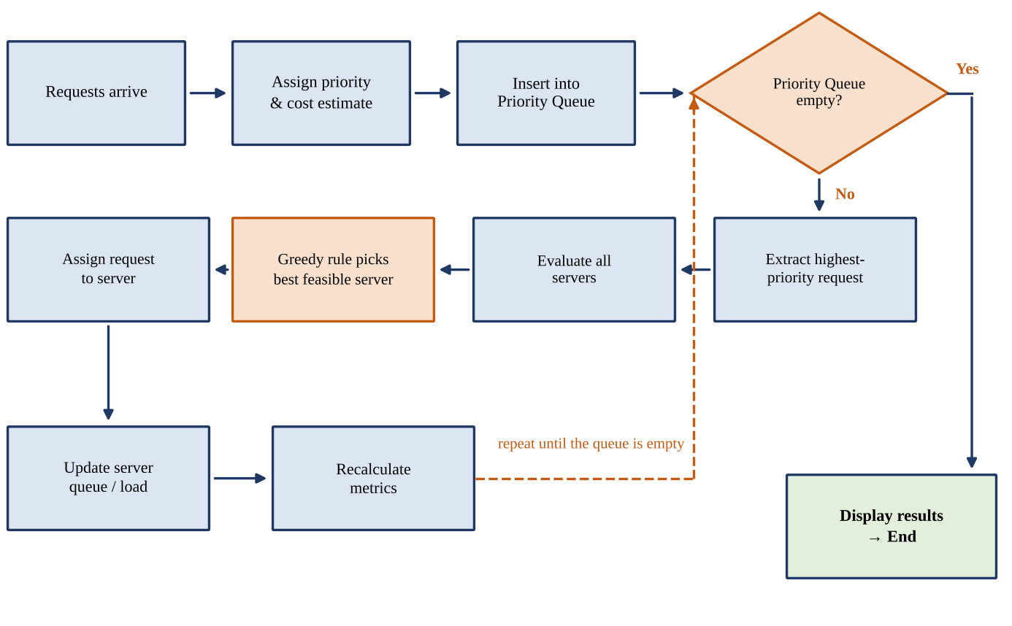
Figure 4: Methodology Flowchart of the Combined Algorithm
while PQ is not empty: // R iterations
r <- PQ_EXTRACT(PQ) // O(log n)
s <- GREEDY_SELECT(servers, r, policy) // O(S)
if s = NIL: defer(r) else: assign(r, s); update(s) // O(1)
log(r, scores, s, reason); update_metrics()
The order in which requests are handled depends only on the Priority Queue, and the server chosen for each request depends only on the current server state. Changing the selection criterion therefore does not affect the ordering logic, and vice versa.

13. Complexity Analysis
Let R be the number of requests, n the number of requests currently held in the Priority Queue (n ≤ R) and S the number of servers.

13.1 Time Complexity
Table 11: Time Complexity of the Main Operations
Operation | Complexity | Explanation
Insert request into Priority Queue | O(log n) | Sift-up along one root-to-leaf path
Remove highest-priority request | O(log n) | Sift-down along one root-to-leaf path
Evaluate S servers | O(S) | One O(1) score computation per server
Greedy server selection | O(S) | Single linear scan for the minimum key
Assign request and update server state | O(1) | Two counters are updated
Process R requests (all queued first) | O(R log R + R·S) | R insertions and R extractions, plus one O(S) selection per request

For one request the cost is O(log n) for extraction plus O(S) for evaluation and selection, that is O(log n + S). Over R requests the total is R·O(log n + S) = O(R log R + R·S) in the worst case, where n ≤ R. If all requests are known in advance, building the heap with BUILD-HEAP takes O(R) instead of R separate insertions, but the R extractions still cost O(R log R). When S is small and fixed the total is O(R log R); when S is large the term R·S dominates.

13.2 Space Complexity
Table 12: Space Complexity of the Data Structures
Structure | Space | Explanation
Priority Queue (heap array) | O(n) ≤ O(R) | One key per pending request
Server table | O(S) | One record per server
Routing history | O(R) | One record per decision (each stores S scores: O(R·S) if scores are kept)
Overall | O(R + S) | Excluding per-decision score lists

13.3 Remarks on Correctness and Optimality
- Selection uses a linear scan because the key E(s, r) depends on the request cost c(r), so servers cannot be kept in one fixed heap; for a request-independent key such as queue length a server heap would reduce selection to O(log S).
- The greedy rule is an online heuristic and is not claimed to be globally optimal. For identical servers, assigning each job to the least-loaded server (list scheduling) is known to keep the maximum load within a factor of 2 − 1/S of the optimum [8]; no such guarantee is claimed here for unequal capacities and latencies.
- With strict priorities, low-priority requests may wait indefinitely; priority ageing is a possible extension (Chapter 18).

14. Technologies Used
The technologies follow the suggestions of Problem Statement 71: Python, Flask and JavaScript, with HTML and CSS for the page structure and appearance. Each technology has one clear purpose, which keeps the algorithms in the backend and the display in the frontend.
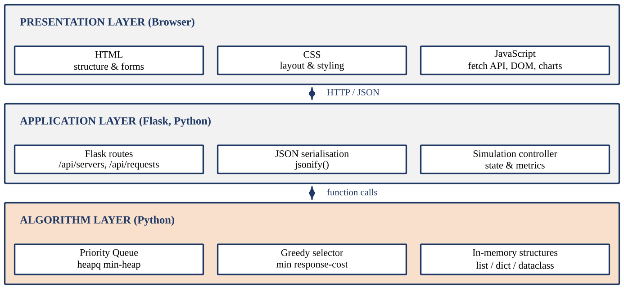
Figure 5: Technology Stack of the Server Request Load Distributor
Table 13: Technologies and Their Purpose
Technology | Layer | Purpose in this project
HTML | Frontend | Structure of the dashboard: server configuration form, request form, result tables and routing history.
CSS | Frontend | Layout, colours and load bars so that queue length and utilisation are easy to compare.
JavaScript | Frontend | Sends requests to the Flask API with fetch, receives JSON and updates tables and bars without reloading the page.
Python | Backend | Implements the simulation, the Priority Queue, the greedy selector and the metrics.
Flask | Backend | Provides REST endpoints (servers, requests, route, metrics) and serves the dashboard page.
Greedy Algorithm | Algorithm | Selects, for each request, the feasible server with the lowest response-cost estimate.
Priority Queue | Algorithm | Holds pending requests and releases the most urgent one first (Python heapq min-heap).

15. System Implementation
The prototype follows a modular architecture. The browser sends JSON requests to a Flask application, which delegates to separate modules for input, server management, the Priority Queue, greedy routing, performance analysis and results. Keeping the modules separate makes each algorithmic step easy to explain and test.
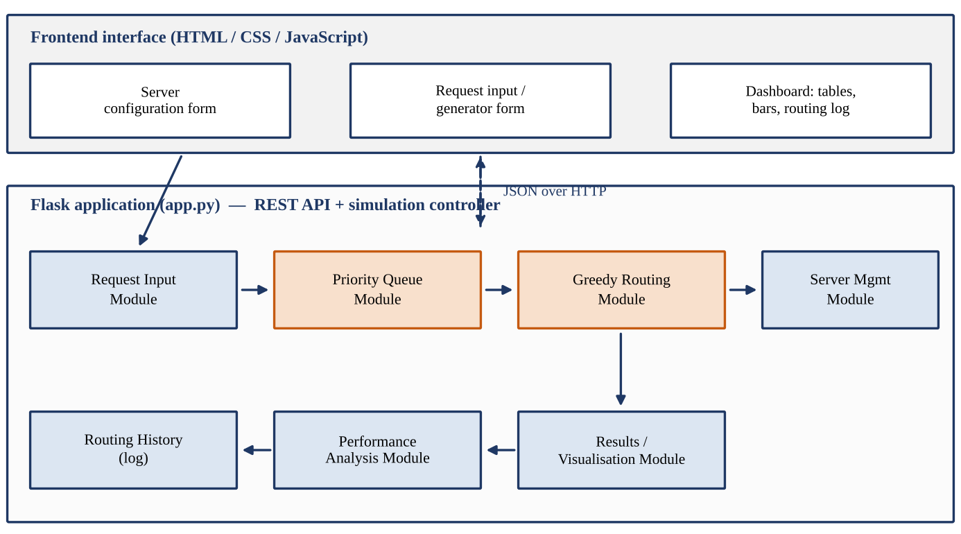
Figure 6: Architecture of the Server Request Load Distributor
Table 14: Implementation Modules
Module | Responsibility
Flask application | Defines the REST API and holds the simulation state in memory.
Frontend interface | HTML forms and a JavaScript dashboard that call the API and draw results.
Request input module | Validates and creates request records (ID, priority, arrival, cost).
Server management module | Stores and updates server capacity, queue length, pending work and availability.
Priority Queue module | Wraps heapq.heappush and heapq.heappop on (priority, arrival, ID) keys.
Greedy routing module | Computes E(s, r) for feasible servers and returns the minimum.
Performance analysis module | Calculates waiting time, utilisation, load spread and distribution.
Results / visualisation module | Formats the decision, history and metrics for the dashboard.

Representative core of the routing module (simplified):
@app.route("/api/route", methods=["POST"])
def route_next():
if not pq: return jsonify(status="empty")
prio, arrival, rid = heapq.heappop(pq) # Priority Queue
s = greedy_select(servers, requests[rid]) # Greedy rule
... # assign, update state, log decision, return JSON

16. Results
Sample / Demonstration Results. The values below are illustrative worked examples obtained by applying the routing rule of Chapter 10 to the stated sample inputs (C in work units/s, L in work units, d = 0.05 s unless stated, E in seconds). They are not measurements from real experiments or a real deployment.
Table 15: Sample Routing Decisions in Four Scenarios
Req | Pri | c | E(S1) / E(S2) / E(S3) | Selected | Reason for selection | Resulting L(q) S1 · S2 · S3
Scenario 1: Balanced server loads. Initial state: S1(C=10, d=0.05, L=20, q=2) S2(C=10, d=0.05, L=20, q=2) S3(C=10, d=0.05, L=20, q=2)
R1 | 1 | 10 | 3.05 / 3.05 / 3.05 | S1 | Tie at E = 3.05; lowest q, then lowest ID | 30(3) · 20(2) · 20(2)
R2 | 2 | 10 | 4.05 / 3.05 / 3.05 | S2 | Tie at E = 3.05; lowest q, then lowest ID | 30(3) · 30(3) · 20(2)
R3 | 3 | 10 | 4.05 / 4.05 / 3.05 | S3 | Lowest E (3.05); next best 4.05 | 30(3) · 30(3) · 30(3)
Scenario 2: One server has a long queue. Initial state: S1(C=10, d=0.05, L=80, q=8) S2(C=10, d=0.05, L=20, q=2) S3(C=10, d=0.05, L=30, q=3)
R4 | 1 | 10 | 9.05 / 3.05 / 4.05 | S2 | Lowest E (3.05); next best 4.05 | 80(8) · 30(3) · 30(3)
R5 | 2 | 20 | 10.05 / 5.05 / 5.05 | S2 | Tie at E = 5.05; lowest q, then lowest ID | 80(8) · 50(4) · 30(3)
R6 | 3 | 10 | 9.05 / 6.05 / 4.05 | S3 | Lowest E (4.05); next best 6.05 | 80(8) · 50(4) · 40(4)
Scenario 3: Servers have different capacities. Initial state: S1(C=20, d=0.05, L=30, q=3) S2(C=10, d=0.05, L=30, q=3) S3(C=5, d=0.05, L=30, q=3)
R7 | 1 | 10 | 2.05 / 4.05 / 8.05 | S1 | Lowest E (2.05); next best 4.05 | 40(4) · 30(3) · 30(3)
R8 | 2 | 10 | 2.55 / 4.05 / 8.05 | S1 | Lowest E (2.55); next best 4.05 | 50(5) · 30(3) · 30(3)
R9 | 3 | 10 | 3.05 / 4.05 / 8.05 | S1 | Lowest E (3.05); next best 4.05 | 60(6) · 30(3) · 30(3)
Scenario 4: Servers have different response-cost estimates. Initial state: S1(C=10, d=0.60, L=10, q=1) S2(C=10, d=0.10, L=10, q=1) S3(C=10, d=0.30, L=10, q=1)
R10 | 1 | 10 | 2.60 / 2.10 / 2.30 | S2 | Lowest E (2.10); next best 2.30 | 10(1) · 20(2) · 10(1)
R11 | 2 | 10 | 2.60 / 3.10 / 2.30 | S3 | Lowest E (2.30); next best 2.60 | 10(1) · 20(2) · 20(2)
R12 | 3 | 10 | 2.60 / 3.10 / 3.30 | S1 | Lowest E (2.60); next best 3.10 | 20(2) · 20(2) · 20(2)
Reading the table. In Scenario 2 the long queue of S1 (q = 8) keeps it out of the competition. In Scenario 3 all three requests go to S1 because its capacity is 2 to 4 times that of the others; a queue-length-only rule would have spread them evenly. In Scenario 4, equal capacities and queues are separated only by the latency estimate d.
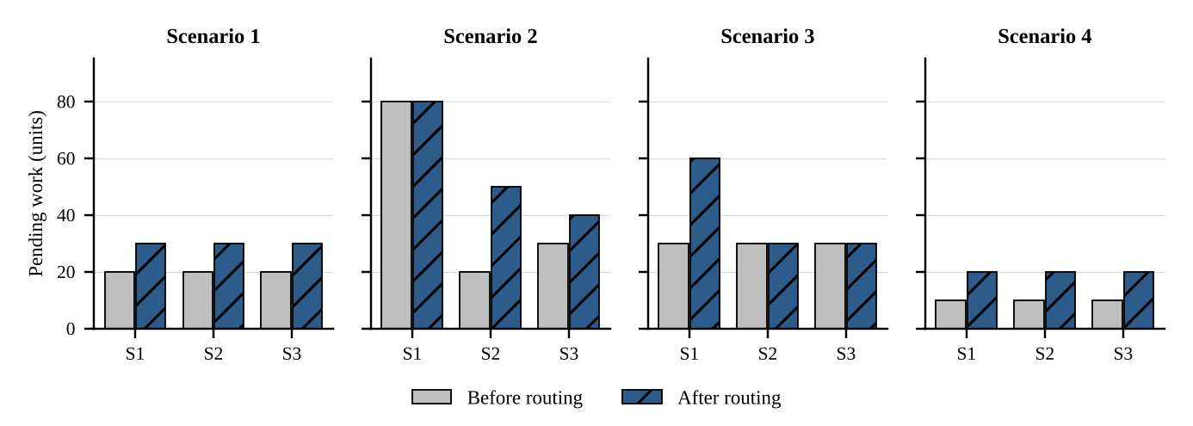
Figure 7: Pending Work per Server Before and After Routing (Sample Values)

17. Testing and Performance Analysis
Each test case was applied to the routing rule using a reference Python implementation of the selection logic. The “simulated result” column therefore shows what the rule produces for that input; the same cases should be re-run on the final prototype.
Table 16: Test Cases and Simulated Results
No. | Test case | Input condition | Expected result | Simulated result | Status
1 | Single server | S = 1, one request | Request goes to the only server | R1 -> S1 | Pass
2 | Multiple servers | 3 equal idle servers, 3 requests | Requests are spread across servers | R1->S1 , R2->S2 , R3->S3 | Pass
3 | Empty queue | Extract with no pending requests | No assignment; “empty” message | No assignment; “empty” message | Pass
4 | High-priority request | p = 3 arrives before p = 1 | p = 1 request is served first | extraction order: Rb , Ra | Pass
5 | Unequal capacity | C = 20 vs 10, equal L and q | Higher-capacity server | S1 (E=2.05) | Pass
6 | Unequal queue lengths | q = 5 vs 1, equal C | Shorter-queue server | S2 (E=2.05) | Pass
7 | High response-cost server | d = 2.0 vs 0.1 | Lower-latency server | S2 (E=2.10) | Pass
8 | Large number of requests | 1000 requests, 5 servers, seed 42 | All assigned, no loss | 1000 assigned; spread of L/C = 2 s | Pass
9 | Server unavailable / busy | S2 down; or all servers full | Skip S2; defer if none feasible | S1 (S2 skipped: unavailable); all full: deferred (None) | Pass
10 | Invalid input | Capacity ≤ 0 or priority < 1 | Rejected with error, no state change | Rejected with error message | Pass

17.1 Performance Analysis (Sample Values)
The metrics below are defined for the dashboard. Numerical values are sample values from the worked scenarios of Chapter 16 and test case 8.
- Average waiting time: mean of L(s)/C(s) over all requests at assignment time; lower is better.
- Server utilisation: share of the observation window during which a server is busy, min(1, L(s)/(C(s)·T)).
- Request distribution, queue length, processing time: requests per server, final q(s), and c(r)/C(s) for each request.
- Response-cost estimate: E(s, r) of the chosen server, averaged over all requests.
Table 17: Greedy Rule versus Round Robin (Average E at Assignment, Sample Values)
Scenario | Greedy | Round robin | Observation
Scenario 1 | 3.05 s | 3.05 s | Equal
Scenario 2 | 4.05 s | 5.72 s | Greedy lower
Scenario 3 | 2.55 s | 4.72 s | Greedy lower
Scenario 4 | 2.33 s | 2.33 s | Equal
In test case 8 the spread of estimated completion times L(s)/C(s) is 2 s under the greedy rule and 399.5 s under round robin, because round robin ignores the unequal capacities (queues were treated as unbounded in this run). These sample values show the behaviour of the rule; they are not benchmark results.

18. Conclusion and Future Scope

18.1 Conclusion
This project addressed Problem Statement 71 by designing a Server Request Load Distributor that simulates request routing and selects servers using queue length, capacity and response-cost estimates. The solution combines two classical algorithms. The Priority Queue, a binary min-heap, orders pending requests by priority and arrival time and supports insertion and extraction in O(log n). The Greedy Algorithm evaluates every feasible server for the released request and irrevocably selects the one with the lowest response-cost estimate in O(S), with deterministic tie-breaking.
The routing process is simple to follow: a request is extracted, the servers are scored, the best one is chosen, the server state is updated and the decision is recorded together with its reason. Compared with plain rotation, this state-aware routing takes queue length and capacity into account, which the sample scenarios show can lower the estimated response cost. The overall cost of O(R log R + R·S) time and O(R + S) space is modest for a prototype. The greedy rule is a heuristic and is not claimed to give a globally optimal distribution, and the prototype is a simulation rather than a production load balancer.
From the DAA point of view, the project demonstrates the greedy choice principle, heap-based priority queues, tie-breaking and deterministic design, Big-O time and space analysis, and the difference between a locally optimal strategy and a global optimum.

18.2 Future Scope
The following extensions are realistic next steps. They are not part of the current prototype.
Table 18: Possible Future Extensions
No. | Extension | Possible contribution
1 | Real-time server monitoring | Replace simulated queue lengths with measured values.
2 | Dynamic server addition / removal | Allow the server set to change during a run.
3 | Machine-learning-based load prediction | Predict request cost or future load to improve estimates.
4 | Adaptive routing policies | Adjust the weights of the selection criterion from observed performance.
5 | Distributed deployment | Run the router and servers as separate processes or machines.
6 | Real server / API integration | Route to actual back-end services and measure real response times.
7 | Advanced load-balancing strategies | Compare with least-connections, weighted and consistent-hashing schemes; add priority ageing against starvation.
8 | Historical performance analytics | Store runs and compare policies over time.
9 | Fault tolerance | Detect failed servers and re-route their pending requests.
10 | Real-time dashboards | Live charts of queue length and utilisation.

19. References
Priority Queue and Greedy Algorithm concepts in this report follow the standard treatments in references [1]–[3]; the Python, Flask and web technology descriptions follow the official documentation in [4]–[7].
[1] T. H. Cormen, C. E. Leiserson, R. L. Rivest, and C. Stein, Introduction to Algorithms, 4th ed. Cambridge, MA, USA: MIT Press, 2022.
[2] A. Levitin, Introduction to the Design and Analysis of Algorithms, 3rd ed. Boston, MA, USA: Pearson, 2012.
[3] J. Kleinberg and É. Tardos, Algorithm Design. Boston, MA, USA: Pearson Addison-Wesley, 2006.
[4] Python Software Foundation, “heapq — Heap queue algorithm,” The Python Standard Library. [Online]. Available: https://docs.python.org/3/library/heapq.html
[5] Python Software Foundation, “Python Documentation.” [Online]. Available: https://docs.python.org/3/
[6] Pallets, “Flask Documentation.” [Online]. Available: https://flask.palletsprojects.com/
[7] Mozilla, “MDN Web Docs: JavaScript, HTML and CSS.” [Online]. Available: https://developer.mozilla.org/
[8] R. L. Graham, “Bounds for certain multiprocessing anomalies,” Bell System Technical Journal, vol. 45, no. 9, pp. 1563–1581, 1966.
[9] DAA Hackathon, “Problem Statement 71: Server Request Load Distributor,” DAA Hackathon problem statement document provided by the organisers. [Details of the issuing document to be added by the team.]

